Discription Diagram

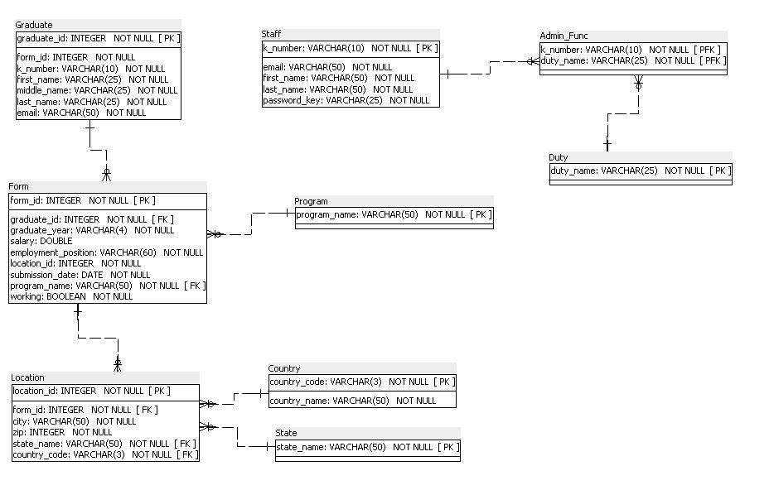

Dictionary Table Graduate

|  |  |  |  |  |  |  |  |
| --- | --- | --- | --- | --- | --- | --- | --- |
| Data Item | Data Type | Data Format | Number of Bytes for Storage | Size for Display | Description | Example | Validation |
| graduate_id | Interger |  |  |  | Unique Identifier For Graduate | 123456 |  |
| form_id | Interger |  |  |  | Unique Identifier For Form | 123456 |  |
| k_number | String | knnnnn |  | 10 | Unique Identifier For Graduate in College | K01234567 |  |
| first_name | String |  |  | 25 | Graduate First Name | James |  |
| middle_name | String |  |  | 25 | Graduate Middle Name | Michael |  |
| last_name | String |  |  | 25 | Graduate Last Name | Green |  |
| Email | String | xxx@xxx |  | 50 | Graduate Email Address | jmg@example.com |  |

|  |  |  |  |  |  |  |  |
| --- | --- | --- | --- | --- | --- | --- | --- |
| Data Item | Data Type | Data Format | Number of Bytes for Storage | Size for Display | Description | Example | Validation |
| form_id | Interger |  |  |  | Unique Identifier For Form | 123456 |  |
| graduate_id | Interger |  |  |  | Unique Identifier For Graduate | 123456 |  |
| graduate_year | String | 1234 |  | 4 | Grad Year | 2017 |  |
| salary | Double | 1234.12 |  |  | Graduate Salary Value | 3500.00 |  |
| employment_position | String |  |  | 60 | Employment Position | Manager |  |
| location_id | Interger |  |  |  | Unique Identifier For Location | 123456 |  |
| submission_date | Date | MM/DD/YYYY |  | 10 | Date of Submission | 03/02/2019 |  |
| program_name | String |  |  | 50 | Name of Program |  |  |
| working | Boolean | 1 |  | 1 | Answer for the Question about Work | Yes |  |

Dictionary Table Form

Dictionary Table Location

|  |  |  |  |  |  |  |  |
| --- | --- | --- | --- | --- | --- | --- | --- |
| Data Item | Data Type | Data Format | Number of Bytes for Storage | Size for Display | Description | Example | Validation |
| location_id | Interger |  |  |  | Unique Identifier For Location | 123456 |  |
| form_id | Interger |  |  |  | Unique Identifier For Form | 123456 |  |
| city | String | xxxx |  | 50 | Name of the city the graduate lives | Iowa City |  |
| zip |  | 1234 |  |  | Number of zip code Address | 52000 |  |
| state_name | String |  |  | 50 | Name of State the graduate lives | Iowa |  |
| country_code | String | XXX |  | 3 | Country Code | USA |  |

Dictionary Table Program

|  |  |  |  |  |  |  |  |
| --- | --- | --- | --- | --- | --- | --- | --- |
| Data Item | Data Type | Data Format | Number of Bytes for Storage | Size for Display | Description | Example | Validation |
| program_name | String |  |  |  |  |  |  |

Dictionary Table Program

|  |  |  |  |  |  |  |  |
| --- | --- | --- | --- | --- | --- | --- | --- |
| Data Item | Data Type | Data Format | Number of Bytes for Storage | Size for Display | Description | Example | Validation |
| country_code | String |  |  |  |  |  |  |
| country_name | String |  |  |  |  |  |  |

Dictionary Table State

|  |  |  |  |  |  |  |  |
| --- | --- | --- | --- | --- | --- | --- | --- |
| Data Item | Data Type | Data Format | Number of Bytes for Storage | Size for Display | Description | Example | Validation |
| state_name | String |  |  |  |  |  |  |

Dictionary Table Duty

|  |  |  |  |  |  |  |  |
| --- | --- | --- | --- | --- | --- | --- | --- |
| Data Item | Data Type | Data Format | Number of Bytes for Storage | Size for Display | Description | Example | Validation |
| duty_name | String |  |  |  |  |  |  |

Dictionary Table Staff

|  |  |  |  |  |  |  |  |
| --- | --- | --- | --- | --- | --- | --- | --- |
| Data Item | Data Type | Data Format | Number of Bytes for Storage | Size for Display | Description | Example | Validation |
| k_number | String | knnnnn |  | 10 | Unique Identifier For Graduate in College | K01234567 |  |
| email | String |  |  |  | Graduate Email Address | jmg@example.com |  |
| first_name | String |  |  |  | Graduate First Name | James |  |
| last_name | String |  |  |  | Graduate Last Name | Green |  |
| password_key | String |  |  |  | Password to access | ***** |  |

Dictionary Table Admin_Func

|  |  |  |  |  |  |  |  |
| --- | --- | --- | --- | --- | --- | --- | --- |
| Data Item | Data Type | Data Format | Number of Bytes for Storage | Size for Display | Description | Example | Validation |
| k_number | String |  |  |  |  |  |  |
| duty_name | String |  |  |  |  |  |  |